Assessment Parameters
- Complete flow of the application with validation and error handling -70%
- Comments/best practice, coding standards – 10%
- Execution of the application (Output) – 20%
- Code with compilation errors will not be considered for evaluation

Internet Service Provider Portal
Problem Statement : An ISP organization Tarangini Limited, wants us to develop an application to help its customers to be able to view and select their internet packages and apply for a connection. The below are the high level requriements.

- Each service package shall comprise of
  - Title: as identity property.
  - Net speed offered in mbps.
  - Max usage per month in GB.
  - Charge per month.
- A list of packages must be available in the database prior to the application initiation.
- The home page shall display
  - The list of these packages
  - User must be able to search for a package based on the cost or net speed or Max Usage
- The New Connection Request page
  - On clicking any of the packages on the home page, the New Connection Reqeust page shall be presented.
  - That page must already have the title of the package selected in the home page.
  - Provision to accept the customer name, mobile, address and time slot (like 9AM to 11AM) suitable for the company technicians for installing the router and activate the connection.
- The New Connection Request page once submitted must insert those details in the database along with the dateOfRequest which is the current system date, and to display a success page with the message “Thank you for your interest. Your order number is <order_number>. Our technicians will see you on <dateOfInstallation> some time in <timeSlot>.
  - The orderNumber has to be auto generated at the time of insertion.
  - The dateOfInterest is exactly 4 days from dateOfRequest excluding Sunday.
  - timeslot as selected by the user.
- The user must be able to navigate to home page from success page.

Marks Distribution:
Criteria | Marks
Repositories | 20
Services and business logic | 30
Controllers | 20
JSP Pages with SpringForm Tags and JSTL | 20
Coding Standards | 10
Total | 100

Sample Home Page (search feature not demonstrated, you will have to include):

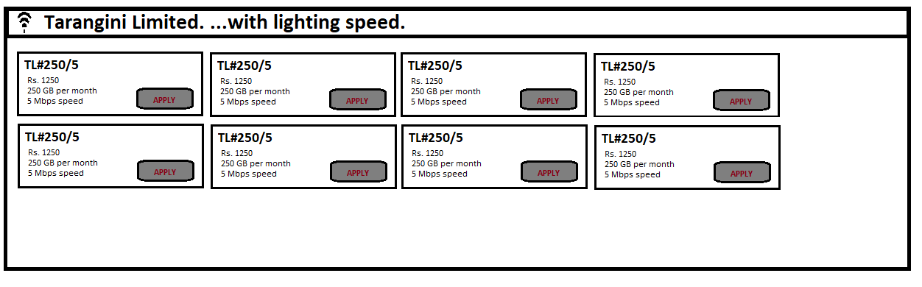
Sample New Connection Page
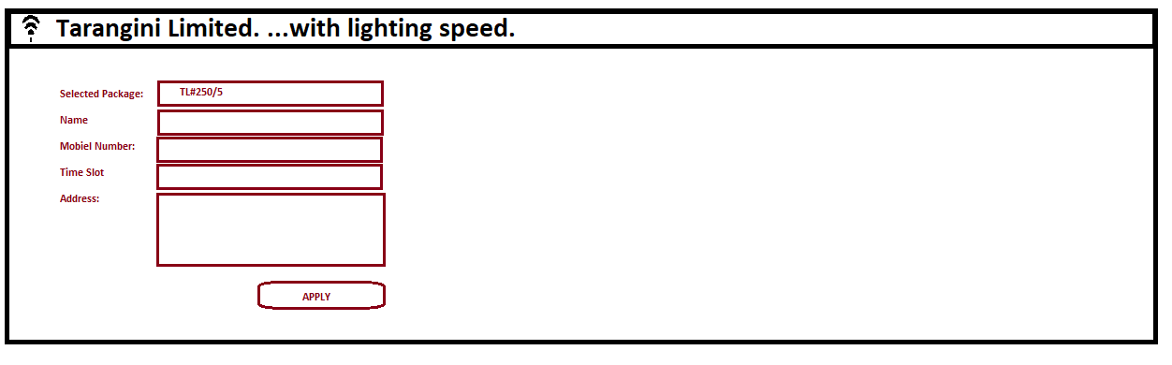
Sample Success Page
